Table of Contents

1. Executive Summary 2

2. Recommendations 3

3. Test Objectives 3

3.1 Test Volumes and Workload 4

4. Test Infrastructure 5

4.1 P&V Test Tools 5

4.2 Server Build & Configuration 5

5. Test Results 5

5.1 Test1- Baseline Test 5

5.2 Test2- Load Test 8

5.3 Result Comparison 11

5.4 TPH Comparison 12

6. Resource Utilization Graphs 13

6.1 Client Machine Graph(Baseline Test) 13

6.2 Client Machine Spike Graph(Baseline Test) 14

6.3 Client Machine Graph(Load Test) 15

6.4 Client Machine Spike Graph(Load Test) 16

6.5 Client Side Graph 17

7. Jira Stories & Reference Documents 20

7.1 Jira Story 20

7.2 Reference Document 21

8. Approval Details 21

# 1. Executive Summary

The Performance Testing and Engineering group executed the performance and volume(P&V) testing on JpetStore release in QA(NA to Demo App) environment post new build introduction to platform. This P&V testing was executed to compare the test result against the baseline figures.

* The Jpet store Test Plan documentation is prepared before the P&V test to track the risks associated with it.
* The Jpet store Work Load Model documentation is prepared to design the scenario and generate the anticipated load on different modules of Jpet Store application.
* 2 rounds of test is executed and completed successfully with minimal test errors which constitutes to less than 1% which is acceptable.
* An expected transaction per hour was closely achieved for all scenarios.
* 95th percentile response time of all scenario transactions are within SLA of 3 sec’s.
* Platform was warmed up before the Load tests to check the connectivity and readiness of application.
* Client machine resource usage in terms of CPU and Memory was within 6% and 70% respectively.
* As this a Demo application and active on production environment so we don’t have access to its QA environment to monitor the real time server utilization.
* We observed some CPU spikes in Baseline test in client machine which lasted for couple of sec’s and the max was at 70%.However it is not touching the threshold limit.
* We observed some CPU spikes in Load test in client machine which lasted for couple of sec’s and the max was at 30%.However it is not touching the threshold limit.

**Test Timings**

|  |  |  |  |  |  |
| --- | --- | --- | --- | --- | --- |
|  | Tests | Date | From | To | Duration |
| JpetStore Baseline | Load Test | 16/07/24 | 4:08 PM IST | 5:08 PM IST | 1 Hour |
| JpetStore Actual | Load Test | 16/07/24 | 5:30 PM IST | 6:30 PM IST | 1 Hour |

# 2. Recommendations

It is recommended to:

1. Ensure the transaction load is as mentioned and considered for QA tests. Any variation/volume increase, platform would need to be re-tested.
2. The transaction which is reported high response time need to be analyzed/tuned and monitored in production.(NA to Demo Apps like JpetStore)
3. P&V team recommends the application team to monitor the transaction growth/workload on periodic basis and update P&V team if any changes to what is been tested in this test.
4. P&V team recommends to monitor the application behaviour, server resource utilization and the database metrics of all servers in production post deployment(NA to Demo Apps like JpetStore)

# 3. Test Objectives

The main objective of this P&V testing is to provide business and technology stakeholders with information validating to :-

* Ensure if any major performance bottleneck does not exist and the overall results are comparable against the baseline test results.
* Ensure all JpetStore transactions are successful and has not degraded the baseline and SLAs.
* All transaction response time must be less than 5 seconds.
* All server resource usage should be within threshold of 80%.
* Response times should be consistent from previous JpetStore release.

|  |  |  |  |
| --- | --- | --- | --- |
| **Server Type** | **CPU Utilization** | **Memory Utilization** | **Disk Utilization** |
| Client Computer | Average should be below 80%.Spikes(>90%) should not extend beyond 2 mins | System memory expected to be below 80% | Average should be below 80% |
| App Server(NA) |
| JVM Parameter(NA) |
| Database(NA) |

## 3.1 Test Volumes and Workload

The following volumetric are considered for test executions. Please check NFR,Test Plan and Work Load Model for more details.

|  |  |  |  |  |  |
| --- | --- | --- | --- | --- | --- |
| **Type** | **Scenario Name** | **Total Users** | **No of Transactions per Scenario(A)** | **Volumes per Hour for each scenario(B)** | **Net TPH(A*B)** |
| UI | Shop Fish | 6 | 9 | 233 | 2097 |
| UI | Shop Dogs | 6 | 9 | 233 | 2097 |
| UI | Shop Reptiles | 6 | 9 | 233 | 2097 |
| UI | Shop Cats | 6 | 9 | 233 | 2097 |
| UI | Shop Birds | 6 | 9 | 233 | 2097 |
|  |  |  |  | **Total TPH** | **10485** |

# 4. Test Infrastructure

## 4.1 P&V Test Tools

* Apache Jmeter 5.6.3
* Monitoring of App servers and Database server through Dynatrace(Not applicable to Demo App like JpetStore)
* Performon Windows OS native monitoring

## 4.2 Server Build & Configuration

Given below are the P&V Application server and Database servers involved:-

**Note: The below servers are given for illustrative purpose only and applicable to real time applications in an project and not applicable to Demo App like JpetStore**

|  |  |
| --- | --- |
| Server Names | IP |
| JpetStore App server1 | pdq8845.unix.jpet |
| JpetStore App server2 | pdq8846.unix.jpet |
| Database Server | pdb : sderfn90  db scan name : sderg1gt-scan.qa.db.jpet  host name: sder01l.unix.jpet |

# 5. Test Results

## 5.1 Test1- Baseline Test

**Test Time: 16/07/2024 04:08 PM – 16/07/2024 05:08 PM(IST)**

**Steady Load Duration: 1 Hour**

Concurrent Users: 30

Total Passed Requests: 10,179

Total Failed Requests: 4

Error/Failure Rate: 0.04%

**\*Response times are in seconds\***

* In Baseline Load test we have closely achieved the required volume for Jpet Store

**Observations:-**

* There are few errors observed in Baseline Test and the count is at 4 nos. However failure rate is below 1% which is acceptable.
* Hourly transactions was closely achieved for all scenarios.This 1st round of Test is Baseline for 2nd round of Load Test.
* We observed few spikes over the test period lasted for couple of seconds.
* 95th percentile response of “SC01_TR08_Jpet_Store_Confirm Info and Continue” transaction is at 1.9 sec’s.
* 95th percentile response of “SC01_TR05_Jpet_Store_Click Add to Cart Large Angel Fish” transaction is at 1.7 sec’s.
* 95th percentile response of “SC02_TR08_Jpet_Store_Confirm Info and Continue” transaction is at 1.9 sec’s.
* 95th percentile response of “SC02_TR05_Jpet_Store_Click Add to Cart Male Adult BullDog” transaction is at 1.8 sec’s.
* 95th percentile response of “SC03_TR08_Jpet_Store_Confirm Info and Continue” transaction is at 2 sec’s.
* 95th percentile response of “SC03_TR05_Jpet_Store_Click Add to Cart Venomless Rattlesnake” transaction is at 2 sec’s.
* 95th percentile response of “SC04_TR08_Jpet_Store_Confirm Info and Continue” transaction is at 1.7 sec’s.
* 95th percentile response of “SC04_TR05_Jpet_Store_Click Add to Cart Tailless Manx” transaction is at 1.7 sec’s.
* 95th percentile response of “SC05_TR08_Jpet_Store_Confirm Info and Continue” transaction is at 2 sec’s.
* 95th percentile response of “SC05_TR05_Jpet_Store_Click Add to Cart Adult Male Amazon Parrot” transaction is at 1.7 sec’s.

|  |  |  |  |  |  |  |  |  |  |
| --- | --- | --- | --- | --- | --- | --- | --- | --- | --- |
| **Transactions** | **SLA** | **# Samples/TPH** | **Average** | **90% Line** | **95% Line** | **Min** | **Max** | **Error %** | **Throughput per Sec** |
| SC01_TR01_Jpet_Store_Launch | 3 | 228 | 1.546 | 1.539 | 1.572 | 0.89 | 22.5 | 0.00% | 0.06354 |
| SC01_TR02_Jpet_Store_Login | 3 | 228 | 2.13 | 2.196 | 2.223 | 1.94 | 6.5 | 0.00% | 0.06354 |
| SC01_TR03_Jpet_Store_Click on Fish | 3 | 227 | 0.534 | 0.563 | 0.589 | 0.49 | 1.3 | 0.00% | 0.06384 |
| SC01_TR04_Jpet_Store_Click onAngel Fish | 3 | 227 | 0.542 | 0.571 | 0.59 | 0.5 | 0.71 | 0.00% | 0.06384 |
| SC01_TR05_Jpet_Store_Click Add to Cart Large Angel Fish | 3 | 227 | 1.852 | 1.645 | 1.755 | 1.45 | 23.6 | 0.00% | 0.06376 |
| SC01_TR06_Jpet_Store_Proceed to Checkout | 3 | 225 | 0.533 | 0.561 | 0.584 | 0.49 | 0.71 | 0.00% | 0.06364 |
| SC01_TR07_Jpet_Store_Enter Payment Details and Billing Address and Click Continue | 3 | 225 | 2.017 | 1.568 | 1.648 | 0.49 | 22.6 | 0.00% | 0.06362 |
| SC01_TR08_Jpet_Store_Confirm Info and Continue | 3 | 225 | 1.725 | 1.689 | 1.998 | 0 | 23.5 | 0.44% | 0.06373 |
| SC01_TR09_Jpet_Store_SignOut | 3 | 222 | 1.583 | 1.651 | 1.686 | 0 | 2.76 | 0.00% | 0.06344 |
| SC02_TR01_Jpet_Store_Launch | 3 | 227 | 2.023 | 1.541 | 1.602 | 0.86 | 22.8 | 0.00% | 0.06343 |
| SC02_TR02_Jpet_Store_Login | 3 | 227 | 2.128 | 2.221 | 2.247 | 1.98 | 4.71 | 0.00% | 0.06319 |
| SC02_TR03_Jpet_Store_Click on Dogs | 3 | 227 | 0.533 | 0.569 | 0.597 | 0 | 0.76 | 0.00% | 0.06366 |
| SC02_TR04_Jpet_Store_Click on BullDog | 3 | 226 | 0.545 | 0.572 | 0.61 | 0.49 | 0.71 | 0.00% | 0.06338 |
| SC02_TR05_Jpet_Store_Click Add to Cart Male Adult BullDog | 3 | 226 | 1.695 | 1.695 | 1.89 | 0 | 23.6 | 0.00% | 0.0639 |
| SC02_TR06_Jpet_Store_Proceed to Checkout | 3 | 225 | 0.538 | 0.575 | 0.619 | 0.48 | 1.1 | 0.00% | 0.06375 |
| SC02_TR07_Jpet_Store_Enter Payment Details and Billing Address and Click Continue | 3 | 225 | 1.59 | 1.553 | 1.605 | 0.49 | 22.6 | 0.00% | 0.06373 |
| SC02_TR08_Jpet_Store_Confirm Info and Continue | 3 | 225 | 1.836 | 1.715 | 1.981 | 1.46 | 23.7 | 0.00% | 0.06371 |
| SC02_TR09_Jpet_Store_SignOut | 3 | 224 | 1.588 | 1.649 | 1.671 | 0 | 5.97 | 0.00% | 0.06376 |
| SC03_TR01_Jpet_Store_Launch | 3 | 228 | 1.795 | 1.539 | 1.589 | 0 | 22.6 | 0.00% | 0.06452 |
| SC03_TR02_Jpet_Store_Login | 3 | 227 | 2.117 | 2.213 | 2.261 | 1.95 | 2.9 | 0.00% | 0.06399 |
| SC03_TR03_Jpet_Store_Click on Reptiles | 3 | 227 | 0.532 | 0.568 | 0.6 | 0.49 | 0.73 | 0.00% | 0.06423 |
| SC03_TR04_Jpet_Store_Click on Rattlesnake | 3 | 227 | 0.548 | 0.579 | 0.627 | 0.49 | 1.09 | 0.00% | 0.06423 |
| SC03_TR05_Jpet_Store_Click Add to Cart Venomless Rattlesnake | 3 | 227 | 1.681 | 1.66 | 1.685 | 1.48 | 23.5 | 0.00% | 0.0641 |
| SC03_TR06_Jpet_Store_Proceed to Checkout | 3 | 227 | 0.536 | 0.563 | 0.59 | 0.49 | 1.02 | 0.00% | 0.06423 |
| SC03_TR07_Jpet_Store_Enter Payment Details and Billing Address and Click Continue | 3 | 227 | 1.625 | 1.545 | 1.597 | 0.51 | 22.6 | 0.00% | 0.06421 |
| SC03_TR08_Jpet_Store_Confirm Info and Continue | 3 | 227 | 1.646 | 1.702 | 2.019 | 0 | 8.04 | 0.44% | 0.06439 |
| SC03_TR09_Jpet_Store_SignOut | 3 | 224 | 1.613 | 1.659 | 1.693 | 0 | 6.02 | 0.00% | 0.06381 |
| SC04_TR01_Jpet_Store_Launch | 3 | 228 | 2.05 | 1.585 | 1.704 | 0.87 | 22.7 | 0.00% | 0.06332 |
| SC04_TR02_Jpet_Store_Login | 3 | 227 | 2.134 | 2.229 | 2.283 | 1.96 | 3.2 | 0.00% | 0.06367 |
| SC04_TR03_Jpet_Store_Click on Cats | 3 | 227 | 0.538 | 0.568 | 0.616 | 0.48 | 1.15 | 0.00% | 0.06392 |
| SC04_TR04_Jpet_Store_Click on Manx | 3 | 227 | 0.55 | 0.588 | 0.636 | 0.5 | 0.93 | 0.00% | 0.06392 |
| SC04_TR05_Jpet_Store_Click Add to Cart Tailless Manx | 3 | 227 | 1.604 | 1.689 | 1.763 | 1.46 | 2.5 | 0.00% | 0.06379 |
| SC04_TR06_Jpet_Store_Proceed to Checkout | 3 | 227 | 0.534 | 0.559 | 0.621 | 0 | 1.08 | 0.00% | 0.06439 |
| SC04_TR07_Jpet_Store_Enter Payment Details and Billing Address and Click Continue | 3 | 224 | 1.813 | 1.562 | 1.629 | 0.51 | 22.6 | 0.00% | 0.06352 |
| SC04_TR08_Jpet_Store_Confirm Info and Continue | 3 | 224 | 1.633 | 1.696 | 1.743 | 0.57 | 8.03 | 0.45% | 0.0635 |
| SC04_TR09_Jpet_Store_SignOut | 3 | 222 | 1.602 | 1.657 | 1.689 | 1.48 | 6 | 0.00% | 0.0632 |
| SC05_TR01_Jpet_Store_Launch | 3 | 229 | 1.719 | 1.529 | 1.618 | 0.88 | 22.8 | 0.00% | 0.06387 |
| SC05_TR02_Jpet_Store_Login | 3 | 229 | 2.254 | 2.217 | 2.281 | 1.93 | 20 | 0.00% | 0.06382 |
| SC05_TR03_Jpet_Store_Click on Birds | 3 | 227 | 0.532 | 0.557 | 0.567 | 0.48 | 0.69 | 0.00% | 0.06368 |
| SC05_TR04_Jpet_Store_Click on Amazon Parrot | 3 | 227 | 0.55 | 0.593 | 0.62 | 0 | 1.07 | 0.00% | 0.06441 |
| SC05_TR05_Jpet_Store_Click Add to Cart Adult Male Amazon Parrot | 3 | 226 | 1.688 | 1.673 | 1.717 | 1.46 | 23.5 | 0.00% | 0.064 |
| SC05_TR06_Jpet_Store_Proceed to Checkout | 3 | 226 | 0.531 | 0.555 | 0.573 | 0.48 | 0.65 | 0.00% | 0.06412 |
| SC05_TR07_Jpet_Store_Enter Payment Details and Billing Address and Click Continue | 3 | 226 | 1.637 | 1.549 | 1.583 | 0.5 | 22.6 | 0.00% | 0.06411 |
| SC05_TR08_Jpet_Store_Confirm Info and Continue | 3 | 226 | 1.676 | 1.728 | 2.092 | 0.56 | 8.04 | 0.44% | 0.06408 |
| SC05_TR09_Jpet_Store_SignOut | 3 | 223 | 1.67 | 1.64 | 1.692 | 0 | 23.7 | 0.00% | 0.06387 |
| TOTAL |  | 10179 | 1.372 | 2.061 | 2.138 | 0 | 23.7 | 0.04% | 2.82679 |

## 5.2 Test2- Load Test

**Test Time: 16/07/2024 05:30 PM – 16/07/2024 06:30 PM(IST)**

**Steady Load Duration: 1 Hour**

Concurrent Users: 30

Total Passed Requests: 10,265

Total Failed Requests: 16

Error/Failure Rate: 0.16%

**\*Response times are in seconds\***

* In Load test we have closely achieved the required volume for Jpet Store

**Observations:-**

* There are few errors observed in Baseline Test and the count is at 14 nos. However failure rate is below 1% which is acceptable.
* Hourly transactions was closely achieved for all scenarios.
* We observed few spikes over the test period lasted for couple of seconds.
* 95th percentile response of “SC01_TR08_Jpet_Store_Confirm Info and Continue” transaction is at 2.4 sec’s.
* 95th percentile response of “SC01_TR05_Jpet_Store_Click Add to Cart Large Angel Fish” transaction is at 1.9 sec’s.
* 95th percentile response of “SC02_TR08_Jpet_Store_Confirm Info and Continue” transaction is at 2.1 sec’s.
* 95th percentile response of “SC02_TR05_Jpet_Store_Click Add to Cart Male Adult BullDog” transaction is at 1.7 sec’s.
* 95th percentile response of “SC03_TR08_Jpet_Store_Confirm Info and Continue” transaction is at 2.4 sec’s.
* 95th percentile response of “SC03_TR05_Jpet_Store_Click Add to Cart Venomless Rattlesnake” transaction is at 1.6 sec’s.
* 95th percentile response of “SC04_TR08_Jpet_Store_Confirm Info and Continue” transaction is at 2.1 sec’s.
* 95th percentile response of “SC04_TR05_Jpet_Store_Click Add to Cart Tailless Manx” transaction is at 1.6 sec’s.
* 95th percentile response of “SC05_TR08_Jpet_Store_Confirm Info and Continue” transaction is at 2.4 sec’s.
* 95th percentile response of “SC05_TR05_Jpet_Store_Click Add to Cart Adult Male Amazon Parrot” transaction is at 1.7 sec’s.

|  |  |  |  |  |  |  |  |  |  |
| --- | --- | --- | --- | --- | --- | --- | --- | --- | --- |
| **Transactions** | **SLA** | **# Samples/TPH** | **Average** | **90% Line** | **95% Line** | **Min** | **Max** | **Error %** | **Throughput Per Sec** |
| SC01_TR01_Jpet_Store_Launch | 3 | 230 | 1.75 | 1.499 | 1.544 | 0.868 | 22.525 | 0.00% | 0.06408 |
| SC01_TR02_Jpet_Store_Login | 3 | 230 | 2.123 | 2.197 | 2.563 | 1.737 | 6.494 | 0.44% | 0.06409 |
| SC01_TR03_Jpet_Store_Click on Fish | 3 | 228 | 0.525 | 0.555 | 0.569 | 0.484 | 1.024 | 0.00% | 0.06434 |
| SC01_TR04_Jpet_Store_Click onAngel Fish | 3 | 228 | 0.536 | 0.568 | 0.597 | 0.491 | 1.116 | 0.00% | 0.06434 |
| SC01_TR05_Jpet_Store_Click Add to Cart Large Angel Fish | 3 | 228 | 1.58 | 1.653 | 1.955 | 1.447 | 2.538 | 0.00% | 0.06421 |
| SC01_TR06_Jpet_Store_Proceed to Checkout | 3 | 228 | 0.527 | 0.56 | 0.592 | 0.484 | 0.67 | 0.00% | 0.06434 |
| SC01_TR07_Jpet_Store_Enter Payment Details and Billing Address and Click Continue | 3 | 228 | 1.392 | 1.489 | 1.546 | 0 | 22.605 | 0.00% | 0.06442 |
| SC01_TR08_Jpet_Store_Confirm Info and Continue | 3 | 227 | 1.972 | 1.988 | 2.479 | 0 | 23.52 | 1.32% | 0.06427 |
| SC01_TR09_Jpet_Store_SignOut | 3 | 220 | 1.567 | 1.647 | 1.691 | 1.444 | 2.127 | 0.00% | 0.06286 |
| SC02_TR01_Jpet_Store_Launch | 3 | 232 | 1.561 | 1.493 | 1.591 | 0.832 | 22.633 | 0.00% | 0.06465 |
| SC02_TR02_Jpet_Store_Login | 3 | 232 | 2.1 | 2.171 | 2.196 | 1.918 | 6.537 | 0.00% | 0.06464 |
| SC02_TR03_Jpet_Store_Click on Dogs | 3 | 231 | 0.522 | 0.56 | 0.578 | 0 | 0.724 | 0.43% | 0.06478 |
| SC02_TR04_Jpet_Store_Click on BullDog | 3 | 229 | 0.536 | 0.573 | 0.61 | 0.226 | 1.027 | 0.44% | 0.06422 |
| SC02_TR05_Jpet_Store_Click Add to Cart Male Adult BullDog | 3 | 228 | 1.65 | 1.614 | 1.728 | 0 | 23.452 | 0.00% | 0.06407 |
| SC02_TR06_Jpet_Store_Proceed to Checkout | 3 | 227 | 0.522 | 0.558 | 0.581 | 0 | 1.043 | 0.00% | 0.06433 |
| SC02_TR07_Jpet_Store_Enter Payment Details and Billing Address and Click Continue | 3 | 225 | 1.389 | 1.497 | 1.554 | 0.487 | 22.52 | 0.00% | 0.06376 |
| SC02_TR08_Jpet_Store_Confirm Info and Continue | 3 | 225 | 1.787 | 2.009 | 2.136 | 0.544 | 23.57 | 0.44% | 0.06375 |
| SC02_TR09_Jpet_Store_SignOut | 3 | 223 | 1.549 | 1.641 | 1.676 | 0.214 | 2.151 | 0.45% | 0.06373 |
| SC03_TR01_Jpet_Store_Launch | 3 | 232 | 1.605 | 1.516 | 1.59 | 0.861 | 22.529 | 0.00% | 0.06443 |
| SC03_TR02_Jpet_Store_Login | 3 | 231 | 2.105 | 2.171 | 2.22 | 1.932 | 6.561 | 0.00% | 0.06436 |
| SC03_TR03_Jpet_Store_Click on Reptiles | 3 | 230 | 0.521 | 0.549 | 0.564 | 0 | 1.037 | 0.00% | 0.06451 |
| SC03_TR04_Jpet_Store_Click on Rattlesnake | 3 | 228 | 0.535 | 0.569 | 0.598 | 0.483 | 1.119 | 0.00% | 0.06395 |
| SC03_TR05_Jpet_Store_Click Add to Cart Venomless Rattlesnake | 3 | 228 | 1.638 | 1.619 | 1.679 | 0 | 23.478 | 0.00% | 0.06428 |
| SC03_TR06_Jpet_Store_Proceed to Checkout | 3 | 227 | 0.525 | 0.548 | 0.572 | 0.483 | 1.054 | 0.00% | 0.06413 |
| SC03_TR07_Jpet_Store_Enter Payment Details and Billing Address and Click Continue | 3 | 227 | 1.101 | 1.487 | 1.532 | 0.482 | 22.455 | 0.00% | 0.06411 |
| SC03_TR08_Jpet_Store_Confirm Info and Continue | 3 | 226 | 1.791 | 2.033 | 2.444 | 0.563 | 23.512 | 0.44% | 0.06429 |
| SC03_TR09_Jpet_Store_SignOut | 3 | 225 | 1.654 | 1.639 | 1.669 | 1.32 | 23.485 | 0.44% | 0.06408 |
| SC04_TR01_Jpet_Store_Launch | 3 | 232 | 1.463 | 1.487 | 1.537 | 0.853 | 22.572 | 0.00% | 0.06453 |
| SC04_TR02_Jpet_Store_Login | 3 | 232 | 2.12 | 2.163 | 2.205 | 0 | 13.436 | 0.00% | 0.06457 |
| SC04_TR03_Jpet_Store_Click on Cats | 3 | 230 | 0.519 | 0.545 | 0.556 | 0 | 0.925 | 0.00% | 0.06449 |
| SC04_TR04_Jpet_Store_Click on Manx | 3 | 229 | 0.536 | 0.568 | 0.6 | 0.485 | 1.012 | 0.00% | 0.06421 |
| SC04_TR05_Jpet_Store_Click Add to Cart Tailless Manx | 3 | 229 | 1.544 | 1.608 | 1.639 | 0 | 2.511 | 0.00% | 0.06478 |
| SC04_TR06_Jpet_Store_Proceed to Checkout | 3 | 228 | 0.53 | 0.56 | 0.602 | 0.477 | 1.112 | 0.00% | 0.06462 |
| SC04_TR07_Jpet_Store_Enter Payment Details and Billing Address and Click Continue | 3 | 228 | 1.391 | 1.484 | 1.55 | 0.478 | 22.551 | 0.00% | 0.06462 |
| SC04_TR08_Jpet_Store_Confirm Info and Continue | 3 | 228 | 1.676 | 2.011 | 2.129 | 0.516 | 8.034 | 1.32% | 0.0646 |
| SC04_TR09_Jpet_Store_SignOut | 3 | 224 | 1.559 | 1.644 | 1.667 | 0 | 2.17 | 0.00% | 0.0639 |
| SC05_TR01_Jpet_Store_Launch | 3 | 231 | 1.574 | 1.484 | 1.561 | 0 | 22.65 | 0.00% | 0.06423 |
| SC05_TR02_Jpet_Store_Login | 3 | 230 | 2.078 | 2.186 | 2.247 | 0 | 2.703 | 0.00% | 0.06453 |
| SC05_TR03_Jpet_Store_Click on Birds | 3 | 229 | 0.523 | 0.547 | 0.577 | 0.484 | 1.007 | 0.00% | 0.0645 |
| SC05_TR04_Jpet_Store_Click on Amazon Parrot | 3 | 229 | 0.538 | 0.58 | 0.619 | 0.485 | 1.091 | 0.00% | 0.0645 |
| SC05_TR05_Jpet_Store_Click Add to Cart Adult Male Amazon Parrot | 3 | 229 | 1.554 | 1.605 | 1.741 | 1.432 | 2.466 | 0.00% | 0.06437 |
| SC05_TR06_Jpet_Store_Proceed to Checkout | 3 | 229 | 0.532 | 0.572 | 0.6 | 0 | 2.039 | 0.00% | 0.0646 |
| SC05_TR07_Jpet_Store_Enter Payment Details and Billing Address and Click Continue | 3 | 228 | 1.509 | 1.503 | 1.538 | 0 | 22.54 | 0.44% | 0.0644 |
| SC05_TR08_Jpet_Store_Confirm Info and Continue | 3 | 225 | 1.853 | 2.037 | 2.402 | 0 | 23.634 | 0.89% | 0.06396 |
| SC05_TR09_Jpet_Store_SignOut | 3 | 222 | 1.551 | 1.629 | 1.655 | 1.444 | 2.137 | 0.00% | 0.06318 |
| TOTAL |  | 10265 | 1.291 | 2.027 | 2.102 | 0 | 23.634 | 0.16% | 2.85082 |

## 5.3 Result Comparison

|  |  |  |  |  |  |  |
| --- | --- | --- | --- | --- | --- | --- |
| **Transactions** | **95% Line Baseline** | **95% Line Load** | **TPH Baseline** | **TPH Load** | **TPH Difference** | **TPH% Difference** |
| SC01_TR03_Jpet_Store_Click on Fish | 0.589 | 0.569 | 227 | 228 | 1 | 0% |
| SC01_TR04_Jpet_Store_Click onAngel Fish | 0.59 | 0.597 | 227 | 228 | 1 | 0% |
| SC01_TR05_Jpet_Store_Click Add to Cart Large Angel Fish | 1.755 | 1.955 | 227 | 228 | 1 | 0% |
| SC01_TR06_Jpet_Store_Proceed to Checkout | 0.584 | 0.592 | 225 | 228 | 3 | 1% |
| SC01_TR07_Jpet_Store_Enter Payment Details and Billing Address and Click Continue | 1.648 | 1.546 | 225 | 228 | 3 | 1% |
| SC01_TR08_Jpet_Store_Confirm Info and Continue | 1.998 | 2.479 | 225 | 227 | 2 | 1% |
| SC02_TR03_Jpet_Store_Click on Dogs | 0.597 | 0.578 | 227 | 231 | 4 | 2% |
| SC02_TR04_Jpet_Store_Click on BullDog | 0.61 | 0.61 | 226 | 229 | 3 | 1% |
| SC02_TR05_Jpet_Store_Click Add to Cart Male Adult BullDog | 1.89 | 1.728 | 226 | 228 | 2 | 1% |
| SC02_TR06_Jpet_Store_Proceed to Checkout | 0.619 | 0.581 | 225 | 227 | 2 | 1% |
| SC02_TR07_Jpet_Store_Enter Payment Details and Billing Address and Click Continue | 1.605 | 1.554 | 225 | 225 | 0 | 0% |
| SC02_TR08_Jpet_Store_Confirm Info and Continue | 1.981 | 2.136 | 225 | 225 | 0 | 0% |
| SC03_TR03_Jpet_Store_Click on Reptiles | 0.6 | 0.564 | 227 | 230 | 3 | 1% |
| SC03_TR04_Jpet_Store_Click on Rattlesnake | 0.627 | 0.598 | 227 | 228 | 1 | 0% |
| SC03_TR05_Jpet_Store_Click Add to Cart Venomless Rattlesnake | 1.685 | 1.679 | 227 | 228 | 1 | 0% |
| SC03_TR06_Jpet_Store_Proceed to Checkout | 0.59 | 0.572 | 227 | 227 | 0 | 0% |
| SC03_TR07_Jpet_Store_Enter Payment Details and Billing Address and Click Continue | 1.597 | 1.532 | 227 | 227 | 0 | 0% |
| SC03_TR08_Jpet_Store_Confirm Info and Continue | 2.019 | 2.444 | 227 | 226 | -1 | 0% |
| SC04_TR03_Jpet_Store_Click on Cats | 0.616 | 0.556 | 227 | 230 | 3 | 1% |
| SC04_TR04_Jpet_Store_Click on Manx | 0.636 | 0.6 | 227 | 229 | 2 | 1% |
| SC04_TR05_Jpet_Store_Click Add to Cart Tailless Manx | 1.763 | 1.639 | 227 | 229 | 2 | 1% |
| SC04_TR06_Jpet_Store_Proceed to Checkout | 0.621 | 0.602 | 227 | 228 | 1 | 0% |
| SC04_TR07_Jpet_Store_Enter Payment Details and Billing Address and Click Continue | 1.629 | 1.55 | 224 | 228 | 4 | 2% |
| SC04_TR08_Jpet_Store_Confirm Info and Continue | 1.743 | 2.129 | 224 | 228 | 4 | 2% |
| SC05_TR03_Jpet_Store_Click on Birds | 0.567 | 0.577 | 227 | 229 | 2 | 1% |
| SC05_TR04_Jpet_Store_Click on Amazon Parrot | 0.62 | 0.619 | 227 | 229 | 2 | 1% |
| SC05_TR05_Jpet_Store_Click Add to Cart Adult Male Amazon Parrot | 1.717 | 1.741 | 226 | 229 | 3 | 1% |
| SC05_TR06_Jpet_Store_Proceed to Checkout | 0.573 | 0.6 | 226 | 229 | 3 | 1% |
| SC05_TR07_Jpet_Store_Enter Payment Details and Billing Address and Click Continue | 1.583 | 1.538 | 226 | 228 | 2 | 1% |
| SC05_TR08_Jpet_Store_Confirm Info and Continue | 2.092 | 2.402 | 226 | 225 | -1 | 0% |

## 5.4 TPH Comparison

|  |  |  |  |
| --- | --- | --- | --- |
| Scenarios | Expected TPH/hr | Achieved TPH/hr | Difference |
| Jpet Store Shop Fish | 2097 | 2047 | -50 |
| Jpet Store Shop Dogs | 2097 | 2052 | -45 |
| Jpet Store Shop Reptiles | 2097 | 2054 | -43 |
| Jpet Store Shop Cats | 2097 | 2060 | -37 |
| Jpet Store Shop Birds | 2097 | 2052 | -45 |

# 6. Resource Utilization Graphs

## 6.1 Client Machine Graph(Baseline Test)

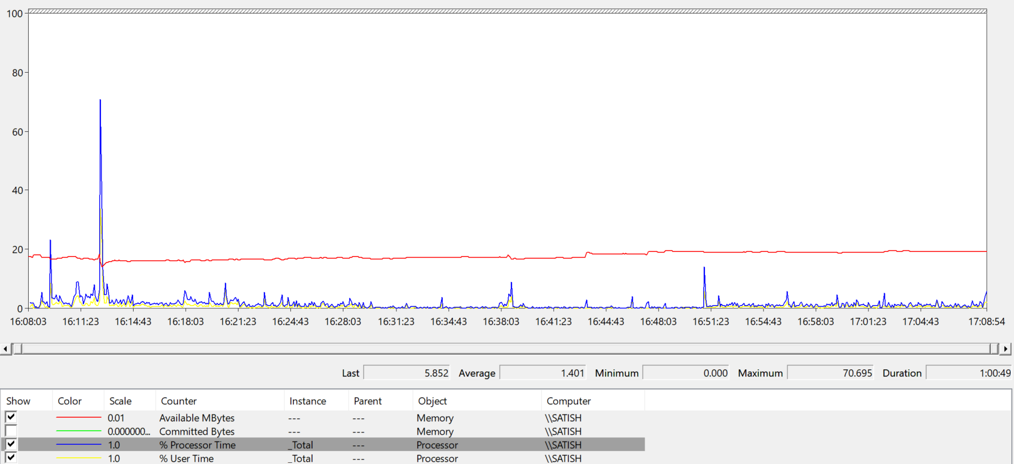

## 6.2 Client Machine Spike Graph(Baseline Test)

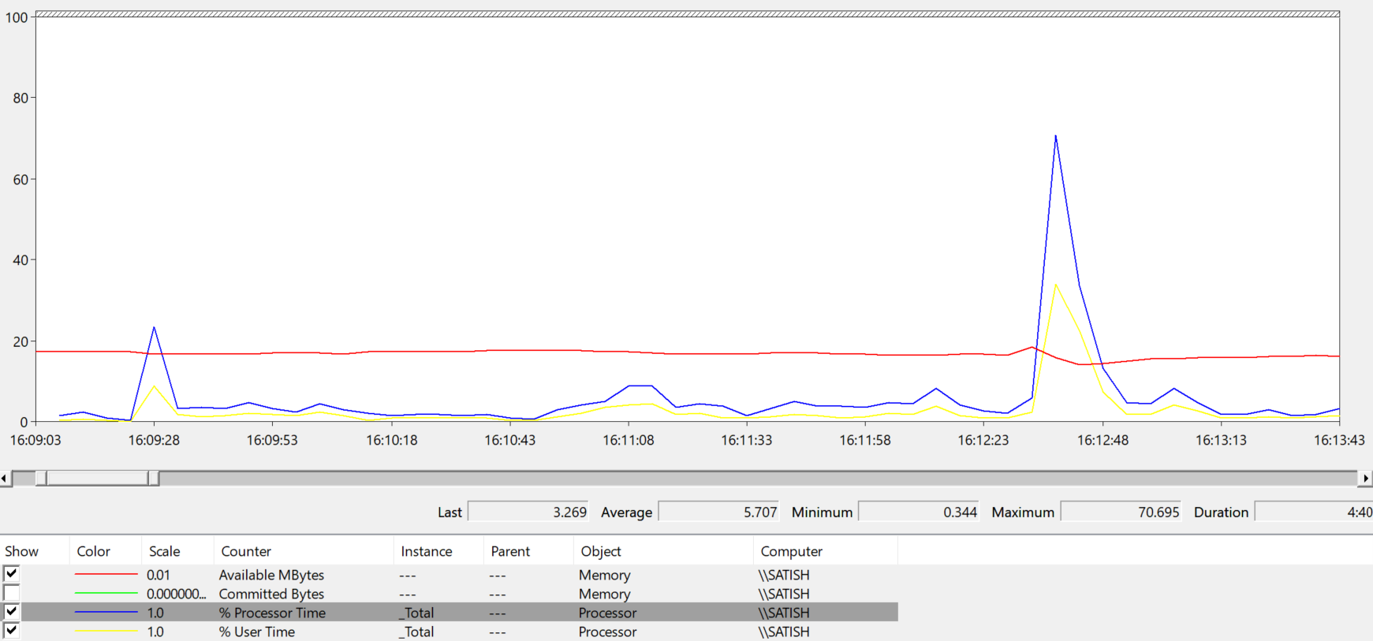

## 6.3 Client Machine Graph(Load Test)

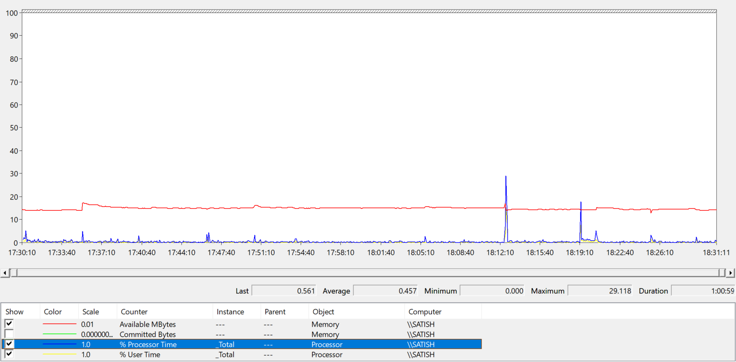

## 6.4 Client Machine Spike Graph(Load Test)

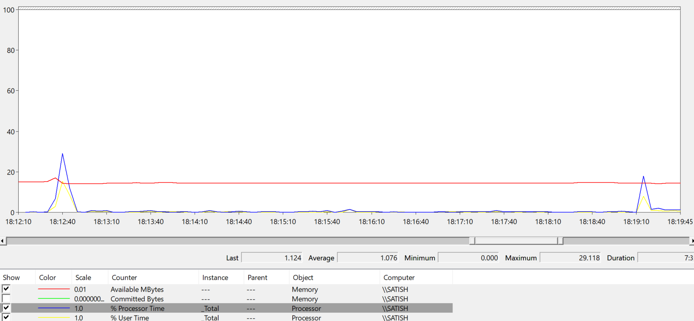

## 6.5 Client Side Graph

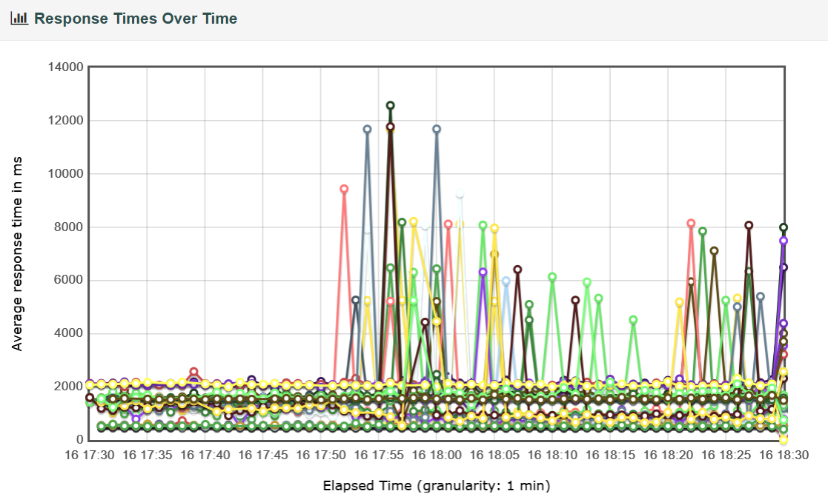

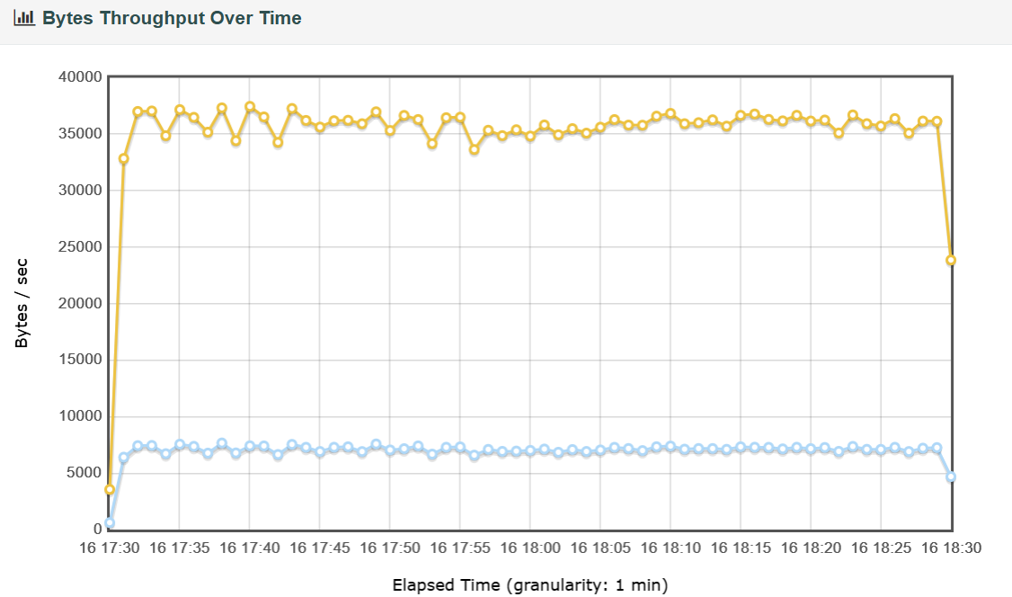

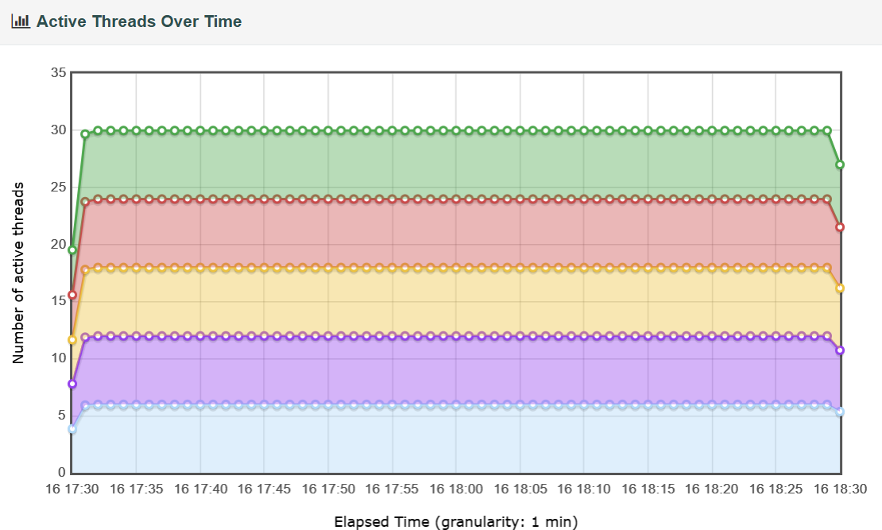

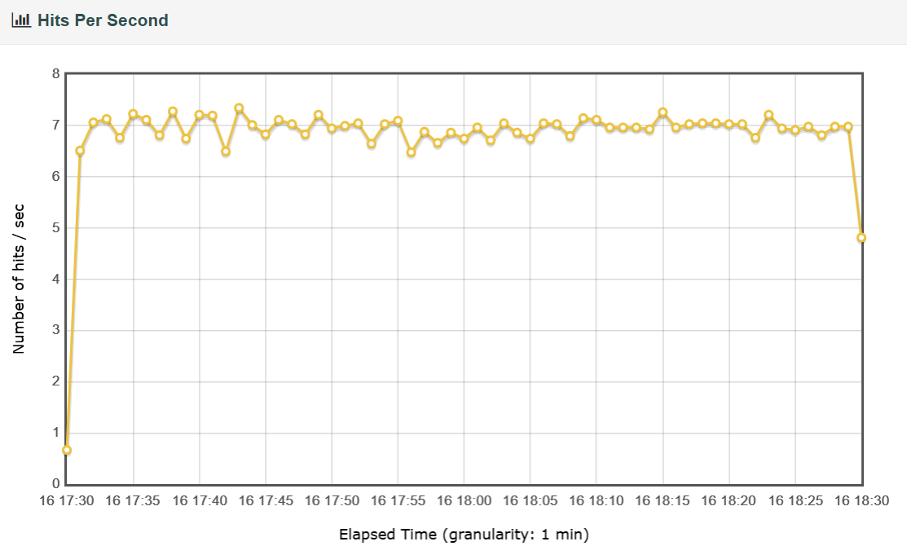

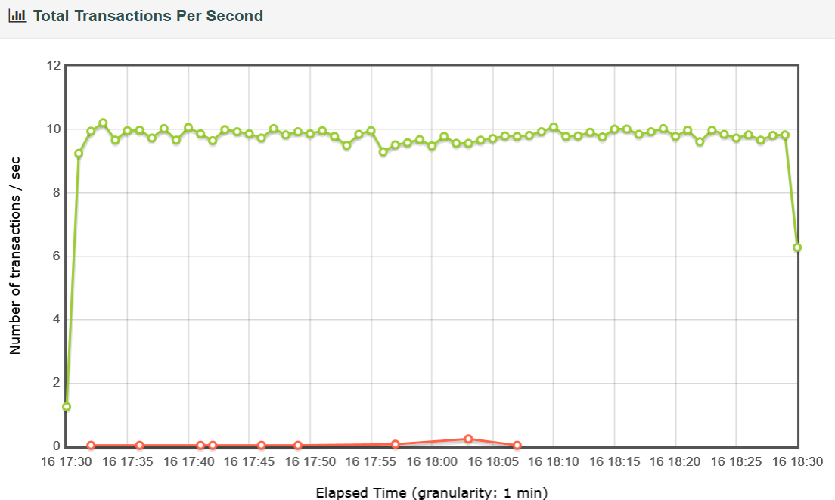

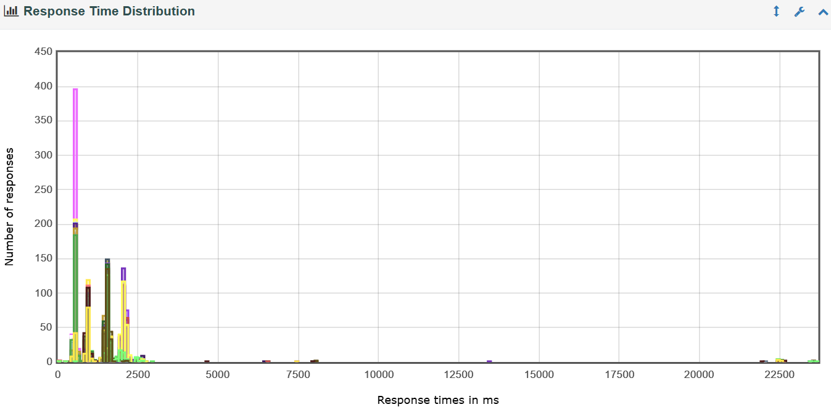

# 7. Jira Stories & Reference Documents

## 7.1 Jira Story

|  |  |  |  |
| --- | --- | --- | --- |
| **Sl No** | **Description** | **Story Link** | **Comments** |
| **1** | **Jpet Store Documentation(POC,NFR,Test Plan,Work Load Model)** | **<Provide Jira Story Link>(NA to Demo App like Jpet Store)** |  |
| **2** | **Jpet Store Scripting and Execution** | **<Provide Jira Story Link>(NA to Demo App like Jpet Store)** |  |
| **3** | **Jpet Store Test Summary Report** | **<Provide Jira Story Link>(NA to Demo App like Jpet Store)** |  |

## 7.2 Reference Document

Non Functional Requirement Doc:- 

Test Plan Doc:- 

Work Load Model:- 

# 8. Approval Details

|  |  |  |  |  |
| --- | --- | --- | --- | --- |
| **Approvers Name** | **Role** | **Approval Date** | **Approval Mode** | **Reference** |
| **James Alfred** | **Platform Chapter Lead** | **19-07-2024** | **Email** | **<Attach Approval Mail>** |
| **Anand Sharma** | **Release Lead** | **19-07-2024** | **Email** | **<Attach Approval Mail>** |
| **P Vijay Kumar** | **Product Owner** | **19-07-2024** | **Email** | **<Attach Approval Mail>** |